**Software Requirements Specification**

**for**

**Smart Hotel Management System**

**Version 1.0**

**Prepared by**

**Asif Zaman,**

**Md Mustansir Zohad,**

**Ahnaf Arnob,**

**AM Nafiz Islam,**

**Asif Iqbal Emon.**

**Technology Hackers**

**2022-10-26**

Table of Contents

Table of Contents ii

Revision History ii

1. Introduction 1

1.1 Purpose 1

1.2 Document Conventions 1

1.3 Intended Audience and Reading Suggestions 1

1.4 Product Scope 1

1.5 References 1

2. Overall Description 2

2.1 Product Perspective 2

2.2 Product Functions 2

2.3 User Classes and Characteristics 2

2.4 Operating Environment 2

2.5 Design and Implementation Constraints 2

2.6 User Documentation 2

2.7 Assumptions and Dependencies 3

3. External Interface Requirements 3

3.1 User Interfaces 3

3.2 Hardware Interfaces 3

3.3 Software Interfaces 3

3.4 Communications Interfaces 3

4. System Features 4

4.1 System Feature 1 4

4.2 System Feature 2 (and so on) 4

5. Other Nonfunctional Requirements 4

5.1 Performance Requirements 4

5.2 Safety Requirements 5

5.3 Security Requirements 5

5.4 Software Quality Attributes 5

5.5 Business Rules 5

6. Other Requirements 5

Appendix A: Glossary 5

Appendix B: Analysis Models 5

Appendix C: To Be Determined List 6

Revision History

|  |  |  |  |
| --- | --- | --- | --- |
| **Name** | **Date** | **Reason For Changes** | **Version** |
|  |  |  |  |
|  |  |  |  |

**1. Introduction**

**1.1 Identification**

Throughout this document, the software is referred to as the SHM and is now known as Smart Hotel. Later, this name might be modified. The SHM is expected to have a version number of 1.0 for its initial release. Its functioning is described in this document. This document has a version number of 1.0.

**1.2 Document Conventions**

The document is written in a very simply way but some format is used to define some special identification. The bold words used for the heading of the contents. The italic are used for the hardware and the software requirements to run the SHM. The italic fonts are used only for the users who will be affected through the software.

**1.3 Intended Audience and Reading Suggestions**

Project managers, domain experts, developers, and requirements engineers are the target audience for this document. It is strongly requested that read the paper to gain an idea of the SHM before reading this document.

**1.4 Product Scope**

The Smart Hotel Management System, which will be developed for a smart Hotel, will automate the majority of the hotel's operations. The Reservation System monitors reservations for rooms and meeting spaces and verifies their availability. All room kinds and services are managed via the room management system. All hotel inventories will be monitored by the inventory control system, and guest information will be managed by guest management. The administration section will keep an eye on everything. For HMS, there are three end users. Owner, Manager, and Receptionist are the end users. Owner has full, unrestricted access to all system features. Managers have limited restrictions and full access to all system features. Only the Reservation management area is accessible to receptionists.

The automated Hotel Management System's goals include streamlining the hotel's regular operations. The system will be able to manage numerous services to quickly take care of all customers. This program will be utilized to get around those issues due to the substantial volume of file handling occurring at the hotel. The development team will highlight several benefits of this system, including security, usability, and—most importantly—the effectiveness of information retrieval. The system should be user-friendly, simple to use, easy to recover from faults, and have high end-user subjective satisfaction overall.

**1.5 References**

[1] Gerald W. Latin, Modern hotel management, W.H.Freeman, 2011.

[2] Michael J. O'Fallon, Denney G. Rutherford, Hotel Management and Operations illustrated

edition, John Wiley & Sons, 2001

**World Wide Web:**

[3]”Hotel Management Case Study”, March.6, 2010. [Online].Available:

http://www.scribd.com/doc/27927992/Hotel-Management-Case-Study, [Accessed: June.28,

2014]

[4]”High-Level-Software Features”, [Online].Available:

http://www.high-level-software.com/features/, [Accessed: June.25, 2014]

[5]Fernandez & Yuan, X,(1999). An analysis Pattern for Reservation and Use of Reusable Entities.

PloP 1999 conference, Retrieved from

<http://hillside.net/plop/plop99/proceedings/Fernandez2/reservanalysisPattern3.PDf>

**2. Overall Description**

**2.1 Product Perspective**

The Smart Hotel System is an independent stand-alone system. It is totally self contained.

The Smart Hotel System is an independent stand-alone system. It is totally self-contained. The newly launched system will make it simple to access the system and will include user-friendly features and aesthetically pleasing interfaces. The system will provide better solutions for the issue of managing big physical file systems, for calculation mistakes, and for all other necessary duties that have been specified by the client. Almost all chores performed at the hotel will become more efficient in the end, and it will be much more convenient.

**2.2 Product Functions**

Selection of one to many item of food.

Booking of item.

Billing of item.

Booking of room

Paying method.

Cancelation of item.

Frequently used item.

Rent car

Manage Users (Add, Update, Delete)

Taking Backups

Manage staffs

Voice command

Email /Chat Notification (to provide their Client everything they need important information about the hotel, booking process,

**2.3 User Classes and Characteristics**

**2.3.1 User Classes**

There are four user levels in the Smart Hotel Management System: **Customer, Manager, Receptionist, and Service Worker**.

2.3.2 Characteristics of User Classes

*Customer:*

Customers are vital part of the system. Customers have access to view the vacant room information and price range. They should be able to confirm the booking and cancel it if necessary. Customers have access to customer service desk portal to forward their inquiry. Customer should at least be capable to use the web UI interface.

*Manager:*

The manager is in charge of managing the resources offered by the hotel management system. The majority of the rights listed above belong to the manager, with the exception of those that deal with handling payments. The goal of using a manager is to lessen the owner's workload by taking on duties that are too important to delegate to the receptionist. The Manager user level has the authority to access all reports in the system, with the exception of information on hotel revenue and financial matters. Managers have additional skills beyond those of user-level receptionists. Examples include adding a new employee to the system, editing or removing them, and adding a new guest to the system, editing or removing them.

*Receptionist:*

The receptionist's job as a hotel employee will be to make reservations and guarantee that every visitor receives superior service. The least accessible position in the hierarchy of system functions is that of the receptionist. The border role in the system is played by the receptionist. He or she is only able to carry out a few tasks, such as adding new guests to the system, making reservations, and reminding customers to confirm their bookings by email. The hotel management will favor hiring receptionists who have a high level of general education and perhaps in areas like English, math, and IT.

*Service Worker:*

Service Workers are available to act as liaisons with guests. If a guest needs a specific service, such as a babysitter, the guest can contact the concierge, who will coordinate the execution of this service. Other services the concierges assist with include making arrangements for dry cleaning and laundry, purchasing show tickets, and making reservations at local restaurants.

**2.4 Operating Environment**

Hardware and software requirements

Hardware:-

1. Operating System supports all known operating systems, such as ***Windows, Linux***

2. Computer ***8GB RAM***, monitor with ***minimum resolution of 1080X720***, keyboard, and mouse

3. ***Hard Drive should be in NTFS*** f i le-system formatted with minimum of ***512GB*** of free space

4. A ***Laser printer*** will need to be used to print these reports and notes

Software:-

1. Software is designed to run on any platform above ***Microsoft Windows 10 (64bit).***

2. Microsoft ***NET Frameworks 4.0*** or above.

3. ***Microsoft SQL Server Management Studio Express 2016***

**2.5 Design and Implementation Constraints**

Software development crew provides their best effort in developing the system. In order to maintain the reliability and durability of system, some design and implementation constraints are applied.

Availability of an android app for hotel management system could make the system portable but due to time constraint it is not possible. System will need a minimum memory of 8GB. But it is recommended to have a memory of 16GB. When designing interfaces of system, we had the capability of work with new tools such as Dev Express. Considering the client's budget we decided to create those interfaces in a simple realistic manner using affordable technology.

**2.6 Assumptions and Dependencies**

Some software used in implementing the system is with high cost and the client has agreed to afford the amount of money needed to purchase them. It’s assumed that client won’t change that decision on the next phases of the software development. Although we assume that client is using windows 7 or windows 10. Otherwise if client use an open source operating system, there is a need of changing the SRS accordingly.

**3. External Interface Requirements**

**3.1 User Interfaces**

The user interface will be very friendly and easy to use. A sample interface is shown here:

User friendly dashboard of system of this Smart Hotel Management System

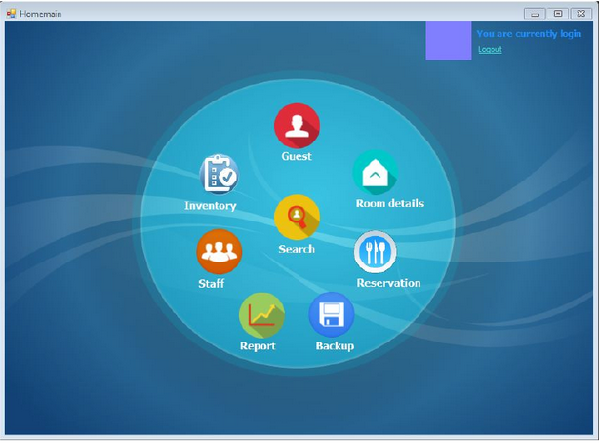

**3.2. Hardware Interfaces**

Various interfaces for smart hotel management systems could be

**Server Side**

Monitor Resolution: 1024 x 768, Processor: Intel or AMD 2GHZ, RAM: 4GB, Disk Space: 10GB

**Client Side**

Monitor Resolution: 1024x768, Processor: Intel or AMD 1GHZ, RAM: 512MB, Disk Space: 2GB

A specific computer must meet the above-mentioned requirements. Reservation alerts will be sent as an e-mail notification to a member of the hotel staff. As a result, a broadband internet connection is required. The client should be able to maintain a stable internet connection. When printing bills and various reports, also a laser printer will be required.

**3.3. Software Interfaces**

**Web Server: Apache** Server, OS (equal to or above Windows 7)

**Language: .**Net 4.0

**Database Server: Microsoft** SQL Server Management Studio Express 2010

This hotel management system requires a computer with a Windows operating system of Windows 7 or above. On the Windows platform. Net 4.0 will be installed, and that will be the platform on which the applications will be operated. ADO.NET data transmission will occur with the installation of the Microsoft SQL Server Management Studio Express 2010 R2 edition on the same PC.

**3.4. Communication Interfaces**

The system shall employ **HTTP/HTTPS** protocol for Internet communication and **TCP/IP** protocol for intranet communication.

When a specific reservation is reserved at the same time, an e-mail notification is sent to both the relevant staff members and the guest's e-mail accounts. The guest will be informed of the check-out date. It is necessary to have a reliable internet connection to use this service. Typically, a broadband connection to the client's PC will give efficient service.

# 4.System Features

Users of the system should be able to retrieve room booking information with the given date/time of check-in and room availability. Customer will have access to the customer functions and the employees have access to both customer and registration functions.

CUSTOMER FUNCTIONS:

*Get all customers who have rooms booked on a given date.*

*View availability of rooms.*

*Get all the rates.*

*Can check their bills*

ADMINISTRATIVE Functions:

*Add/Delete a registration*

*Add a new registration*

*Update rates*

*Add a new event place*

*Add a discount for particular category*

## 4.1 Customer control features

4*.1.1 Description and Priority*

*The customer should be able to register with their details. Of course, this feature is of high*

*priority because without registration one cannot have access of any functions or feature*

*The customer should be able to register with their details. Of course, this feature is of high*

*priority because without registration one cannot have access of any functions or feature*

*The customer will get the booking confirmation e-receipt in which all the details will be shown. This feature is of high priority because without booking confirmation customer will not be allowed to proceed further.*

*4.1.2 Stimulus/Response Sequences*

*• Insert the check-in and check-out date and time for the booked room.*

*Cancel the booking if having the free cancelling package.*

*• Pay online if customer wants to pay in advance.*

*Search for all the room rates*

• Insert the check-in and check-out date and time for the booked room.

Cancel the booking if having the free cancelling package.

• Pay online if customer wants to pay in advance.

*4.1.3 Functional Requirements*

*REQ-1: Customer login*

*Customers can easily log into the system and the password is generated by the management. The user interface Is so easy to understand and to attractive that can ease the login process of the customer into the hotel management system.*

*REQ-2: Customer can book the room*

*The hotel management system monitors booking engine data, checks room status and availability, and shows available rooms via a variety of channels. Additionally, this module keeps track of double bookings and group reservations. Additionally, it allows the front desk employees to change client reservations and schedules bookings. It also shows information about past and present bookings.*

*REQ-3: Automatic check in and out by the system*

*Sometimes there is a big issue in the hotels that Is the late night service problem. So it is too hard for the management to assign the two shifts of the staff and the managers. The hotel management system can solve the issue because it has an automatic check in and check out system. When a customer wants to check in to the hotel no matter what the time is, He can easily check in by the system with the proper accuracy of the room vacancy.  In addition the same thing happens when a customer wants to check out at any time. But during the checking out of a customer the required functionalities are fulfilled and required information are taken for the safety.*

## 4.2 Management control features

REQ-1: Keep track the reservations

Management can track the reservations and bookings and the filled rooms. There is no chance to collide with the booking room and the room which is already reserved, Which is really important for the customer satisfaction and the VIP environment And as well as to make the management system simpler.

REQ-2: Track customer feedback

All the customers are like angels for a hotel. Actually the hotel business is dependent on the hospitality and the customer satisfaction. So customer feedback and the customers view is really important to check what are the laking of the hotel or the management system. Track the customer feedback, the hotel management system has an option to check the feedback of the customer who has already checked out.

REQ-3: Change the information

The management has the right to change any password of any guest if an issue occurs regarding the security. The room number, the plan, check-out date the all the things can be modified by the management.

REQ-5: Inclusion and Exclusion of data

The hotel management system allows for the inclusion and the deletions of data such as room rates, menu items, prices, and user profiles.

# 5. Other Nonfunctional Requirements

**5.1 Performance Requirment**

Acceptable system functionality response times are defined by performance requirements.Even though the system was designed to have the lowest possible system performance, the system's performance will largely depend on how well the computer that installed it uses its hardware and software.The load time for user interface screens should not exceed two seconds when considering the system's timing relationships.It facilitates rapid system function access.Within five seconds, the log in information must be verified to ensure the system's efficiency.The search function is more accurate when it returns query results within five seconds.

* 1. **Safety Requirements**

A user log in screen that requires a user name and password to access the various subsystems protects access to the Smart Hotel Management system's various user levels. This provides various user-level views and system-accessible functions. Backups ensure the security of the system database .In the event of an emergency, the system can be restored.

**5.3 Security Requirements**

The Smrat Hotel Management System will be accessible to owner and customer service representatives. The Reservation/Booking and subsystems will be accessible to Customer Service Representatives.Both the Reservation/Booking subsystems and the Management subsystem will be accessible to managers.The Owner has full access to all subsystems.A user login screen that asks for a user name and password to gain access to the various subsystems will serve as a security measure

**5.4 Software Quality Attributes**

• Availability: - The system shall be available during normal hotel operating hours

• Correctness: - extent to which program satisfies specifications, fulfills user's mission objectives

• Efficiency: - How much less number of resources and time are required to achieve a

particular task through the system.

• Flexibility: - Ability to add new features to the system and handle them conveniently.

• Integrity: - How the system would insecure the information in the system and how it avoids the data losses. Referential integrity in database tables and interfaces

• Maintainability: - How easy is to keep the system as it is and correct defects with making changes.

• Portability: - The Hotel Management System shall run in any Microsoft Windows environment

• Reliability: - Specify the factors required to establish the required reliability of the software system at time of delivery. Mean time between failures and mean time to recovery

• Reusability: - What is the ability to use the available components of the system in other

systems as well.

• Testability: - Effort needed to test to ensure performs as intended

• Usability: - How easily a person can be taken the benefits of the system and the user friendliness.

• Robustness: - Strength of the system to handle system functions accurately and maintain the database without facing to unexpected failures

• Maintainability: - What design, coding standards must be adhered to exclusions created

**5.5 Business Rules**

Smart Hotel Management System will perform under three users which are Owner, Manager and Receptionist. The system is designed in a way where responsibility and privileges are decreased in the order of owner, manager and receptionist. The role of manager is elected in the aim of making the owner's hands free from regular interfering with the system. So, most of the privileges that owner has are given to manager, except the ones are critical and important. Some features like that are, taking backup, restoring of the system and handling financial details, hotel income reports of the system. Receptionist is given with the most frequently used features of the system which has less responsibility than the other two users. Deleting of any information in the system is only allowed for the owner of the hotel.

**6. Other Requirements**

When the system is completely developed and submitted to the client, few sessions will be required to make the users of the system understand about the functionality of it and some time to adapt to the system. After those sessions, it's required that a member from the development team should spend sometime in the system background for an agreed time period. That time period will be used in identifying new bugs that could not be reached in the earlier phases of the development process.

Client should have a valid e-mail account in order to receive reservation e-mail notifications.

**Appendix A: Glossary**

Check-out - settle one's hotel bill before leaving

Check-in - the process whereby a guest announces their arrival at the hotel

**Appendix B: Analysis Models**

Analysis model operates as a link between the 'system description' and the 'design model'.

In the analysis model, information, functions and the behaviour of the system is defined and these are translated into the architecture, interface and component level design in the 'design modeling'.  
  
There is some important elements of analysis model which are data flow diagram, Uml diagram etc.  
**DATA FLOW DIAGRAM**

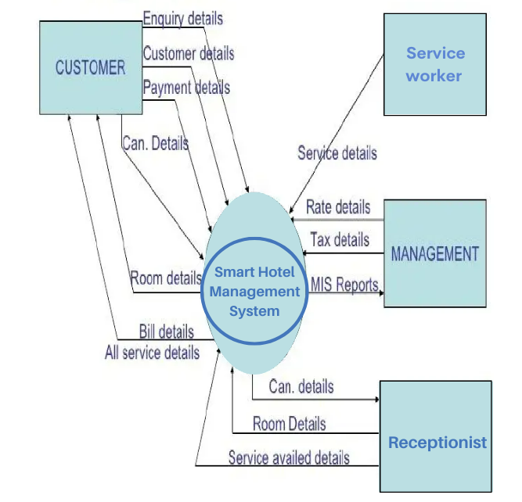

E-R Diagram

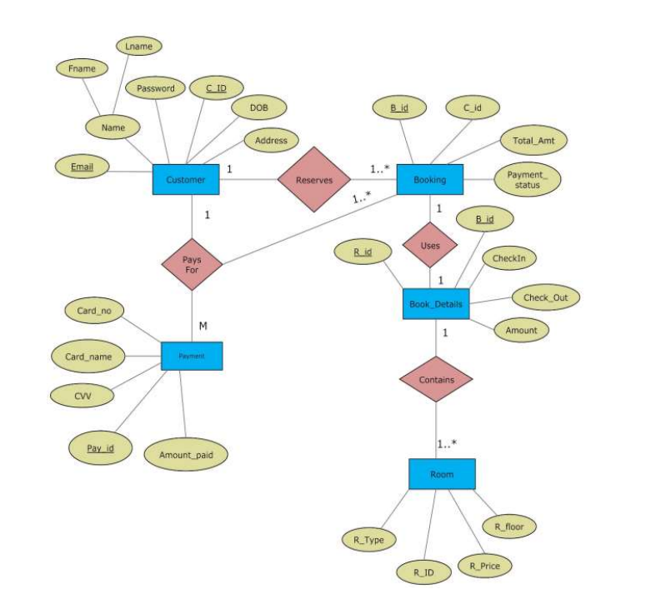

Every element in the model helps in understanding the software requirement and focus on the information, function and behaviour of the system. The analysis model gives value to all the people related to model. A model should be simple as possible. Because simple model always helps in easy understanding of the requirement.